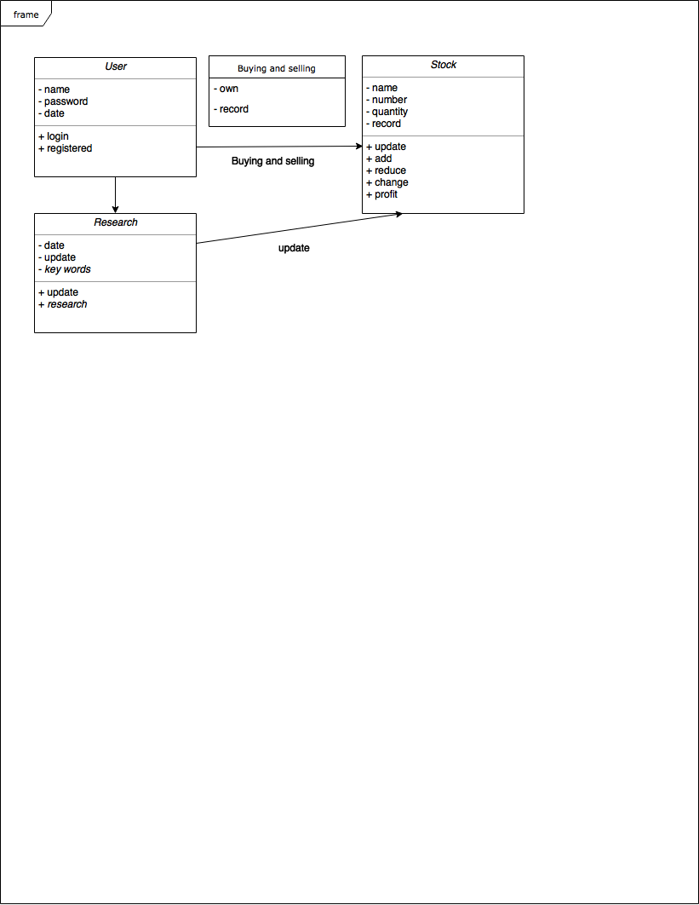**Class diagram- Wang Yi fan**